Suffering
Franklin D. McMillan

Abstract
We understand suffering to be a matter of feelings, but the true nature of this experience has for centuries remained elusive. It is clear that suffering comes into existence when any negative affect reaches a certain intensity – by magnitude, duration, or frequency – but why and how it comes into being is unclear. A key to the mystery of suffering is its strong link to motivation, and this information opens the door to more objective measurement and better approaches to protecting animals from its destructive effects.

Suffering is a mystery. We all know what it is, and yet an understanding of its true nature has continued to elude us. It is the one thing that has towered above all others in our care of nonhuman animals (hereafter animals), and our foremost efforts are devoted to its prevention and alleviation.

What is suffering?
There is currently no universally accepted definition of suffering in any species, animal or human. Even within the veterinary community there is substantial disagreement on the meaning of suffering in animals. Baumgartner et al (2016) studied reports from 42 veterinary experts and found “evidence of disputes between experts concerning the definition of suffering, the significance of clinical findings and the relevance of different assessment methods.”

Remarkably, despite its incomparable importance for the welfare of humans and animals, the scientific literature in both fields contains surprisingly little information. Barnard (2007) made note of this when he wrote that suffering “is a putative negative subjective state that is rarely defined, either in terms of what it comprises or of where on a presumably sliding scale of negativity it lies.” Among the definitions that have been published, physician Eric Gregory (2004) suggested that suffering is “the mental state associated with unpleasant experiences such as pain, malaise, distress, injury and emotional numbness (e.g. extreme boredom),” and Fraser (1988), referring to animals, wrote that “Suffering is essentially the experience of negative feeling in the spectrum from pain, through malaise, to frustration.”

However, these definitions appear to be the exception, whereas the rule seems to be that the intensity of the unpleasant experience is a necessary element of suffering, where intensity refers to the magnitude, duration, and/or frequency of the adversity, or, stated differently, the “quantity” of adversity. For example, suffering has been defined or described as (all emphases added): “the state of severe distress” (Cassell, 2004), “refers to a wide range of intense and unpleasant subjective states of people or other animals, such as fear and frustration” (Dawkins, 1980), “a highly unpleasant emotional state associated with more-than-minimal pain or distress” (DeGrazia, 1996), “negative subjective affects that animals are likely to experience where the impact of their character, intensity, and/or duration [are] sufficiently aversive or extreme” (Ledger and Mellor, 2018), “strong, negative affective states such as severe hunger, pain, or fear” (Baumgaertner et al., 2016), “experiencing intense and prolonged unpleasant states” (Fraser and Duncan, 1998), and “the physical and emotional syndrome that develops as a result of unrelieved severe pain” (Short, 1998). These scientific views are consistent with the common day-to-day usage of the term, in which suffering refers to not just any unpleasant experience – like a mild itchiness, feeling a little bit cold, or a slight bit of anxiety – but to a very unpleasant experience. This conceptualization of suffering involves a threshold of unpleasantness, above which suffering exists and below which it does not. This does not mean that there cannot be mild suffering, just that even the mild forms exceed the threshold. Importantly, the concept of a threshold raises questions crucial for managing and alleviating suffering: What is the nature of the threshold? What creates it and what affects it? We will return to these questions later.

Precision in the defining of suffering literally becomes pivotal in the legal arena, where obtaining a conviction for animal cruelty may hinge on proving that an animal has suffered (Fordyce, 2017). While the word “suffering” often appears in the wording of the applicable law, rarely does the language include a statutory definition (Fordyce, 2017). A typical example is the Minnesota statute that defines “abuse” and “cruelty” to mean the causing (abuse, cruelty) or allowing (cruelty) of unnecessary pain or suffering to a pet or companion animal. In such cases, the evidence provided through the expert testimony of a veterinarian requires an understanding of what suffering is and how is it recognized.

Elements of suffering
Few statements are more obvious than suffering involves feelings, or affect. Affect is often regarded as the feeling experienced in connection to an emotion or mood, but the definition used in the present paper is the broader interpretation of Fredrickson (2001), who wrote that affect “refers to consciously accessible feelings. Although affect is present within emotions (as the component of subjective experience), it is also present within many other affective phenomena, including physical sensations, attitudes, moods, and even affective traits.” Affect can be positive (pleasant, agreeable) or negative (unpleasant, disagreeable); the latter is of course that which pertains to suffering. I will use negative affect (NA) to mean any unpleasant feeling, and it is equated to aversiveness. Examples of physical-based NA include pain, illness, breathlessness (air hunger), thirst, hunger, nausea, urinary bladder distention, pruritus, and temperature extremes; examples of emotion-based NA include fear, anxiety, frustration, boredom, helplessness, hopelessness, social isolation and loneliness, depression, grief, and separation distress (Cassell, 2004; Ledger and Mellor, 2018). All unpleasant feelings – whether physical- or emotion-based – when intense enough, may constitute (or create) suffering.

The function of suffering: Affect and motivation as the core elements
Let us now consider why suffering evolved; that is, its function and value. First, the function of affect in general has been a topic of discussion for several decades among psychologists, emotion theorists, evolutionary biologists, ethologists, and philosophers. It is now widely accepted that affect is adaptive, acting as a guide to facilitate behavior that is beneficial to reproductive fitness and to discourage behavior contrary to these goals (Dawkins, 1990; Panksepp, 1998; Heilman, 2000). Unpleasant affect is, by evolutionary construction, a motivational state intended to elicit behavioral responses to correct a situation that threatens the individual’s well-being or life, while also serving to alert the animal to threats and to focus attention on the immediate threat and not on matters less relevant (at that moment) to survival (Panksepp 1998; Schultheiss and Wirth, 2018). Further, particularly germane to suffering is the fact that as the unpleasantness of NA increases in intensity, so too does the intensity of motivation (Mellor 2016).

Suffering, on this account, is an affective state instilled with the strongest intensity of motivation in order to rectify the imminent threat. Perhaps the clearest illustration of the connection between suffering and motivation is in the context of torture. Torture is the external activation of the body's natural affective mechanisms, but done in a way that amplifies the negative affective experience to a much greater level than is typically encountered in one’s natural life. The important point is that the primary objective of torture is to create an extreme level of motivation to compel an individual to do something they are resistant to doing. And because NA can be physical-based or emotion-based, either of these can be elevated to the level of torture; for example, respectively, physical pain and social isolation (Grassian, 1983).

The suffering-motivation relationship led Dawkins (1990) to suggest that animals often suffer in situations in which they are prevented from doing something that they are highly motivated to do. As we will see, this notion has important implications for measuring suffering.

The evidence for the close association of motivation and suffering is convincing; however, there appear to be limitations on the evolutionary value of suffering, as Broom (2008) noted when he wrote that extreme suffering is “probably not adaptive.” Specifically, research indicates that extreme adversity can overwhelm the individual’s reserves of resilience, overtax coping skills and the ability to manage stress, and create feelings of loss of control, hopelessness, and despair (Seery, 2011).

Revisiting the question: What is suffering?
We have looked at the proposed definitions and evolutionary function of suffering, which at a glance seems to be a relatively complete accounting. But it is not. We still have not actually answered the question of what suffering is; that is, What is the nature of suffering? Consider gravity as an analogy. One can define gravity as a “force that attracts objects toward one another” (Cambridge Dictionary, 2020), but this merely describes how gravity acts; it does not explain what gravity actually is. (Einstein, for example, theorized that gravity isn’t a force at all, but rather a curvature of time and space caused by mass and energy.) So, then, what is suffering? Nobody knows for sure.

What we do know is that, as the intensity of an NA (which I will call the primary NA) increases, there arises at some point an extremely aversive experience we call suffering. And while this is happening, the primary affect remains present. As Ledger and Mellor (2018) wrote, “note that when specific negative affects approach their extreme, they are not transformed into an experience of "suffering"; rather, they retain their original character so that, for example, intense breathlessness continues to be experienced as breathlessness. The same is true for thirst, hunger, pain, nausea, anxiety, fear, panic, or depression, as these and all other such negative experiences also retain their individual character when they are present at high intensities.”

Evidence indicates that suffering is a highly adaptive, “rescue” process for an animal who perceives itself in grave danger. But because intensified affect is itself highly motivating, this leaves unanswered the fundamental question about the nature of suffering: Is suffering merely an intense NA or something in addition to the primary NA? That is, as NA rises in intensity (recall that intensity consists of magnitude and/or duration), does this NA become suffering or elicit suffering? The central question, then, is whether suffering differs qualitatively or only quantitatively from less intense NA, and the difficulty of determining which is correct is encapsulated by philosopher David DeGrazia (1996):

Suffering is a highly unpleasant emotional state associated with more-than-minimal pain or distress. The words “associated with” bypass the difficult conceptual and scientific issue of whether more-than-minimal pain and distress cause or are forms of suffering. (italics in the original)

If there is only a quantitative difference, this means that as NA – e.g., fear, nausea, pain, anxiety, loneliness – intensifies, we simply attach the label of suffering when it becomes highly aversive (see Figure 1a). For the second possibility – that the suffering experience differs qualitatively from less intense NA – as the NA rises in intensity, a new experience is “added onto” the intensifying primary affect (which, as noted, remains present). In this conceptualization, suffering is an affective experience of its own, and accompanies the increasingly intense primary NA to create what is perceived subjectively as a singular experience: suffering-from-the-NA (see Figure 1b). In this case, the suffering affect never exists on its own – there is no experience that is “just suffering” – but rather it always exists secondary to, and concurrent with, the primary affect.

Succinctly, it appears that as NA intensifies, it either simply acquires a new name, or it acquires a new experience and new name.

Both of these two different natures of suffering involve a threshold concept. And that threshold is very indistinct – like any “line” separating day from night. We can reason that, if there is no qualitative difference between suffering and intense NA, then the threshold is merely that point where the NA gains the additional label of suffering. If suffering is a qualitatively different phenomenon, then the threshold is that point where the additional suffering affect begins to emerge.

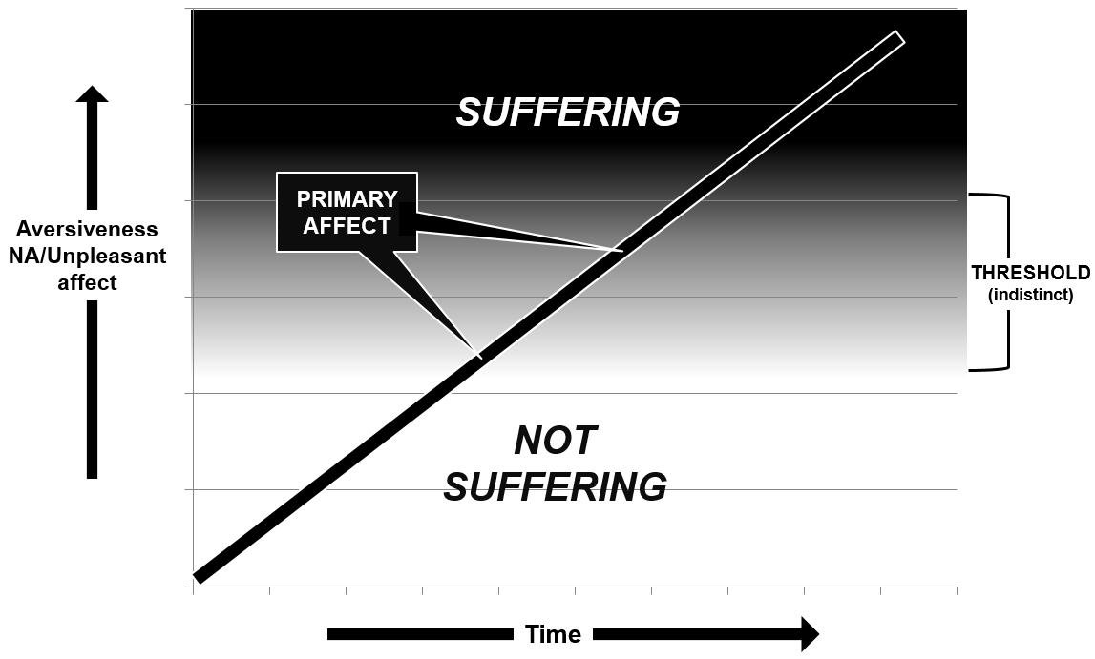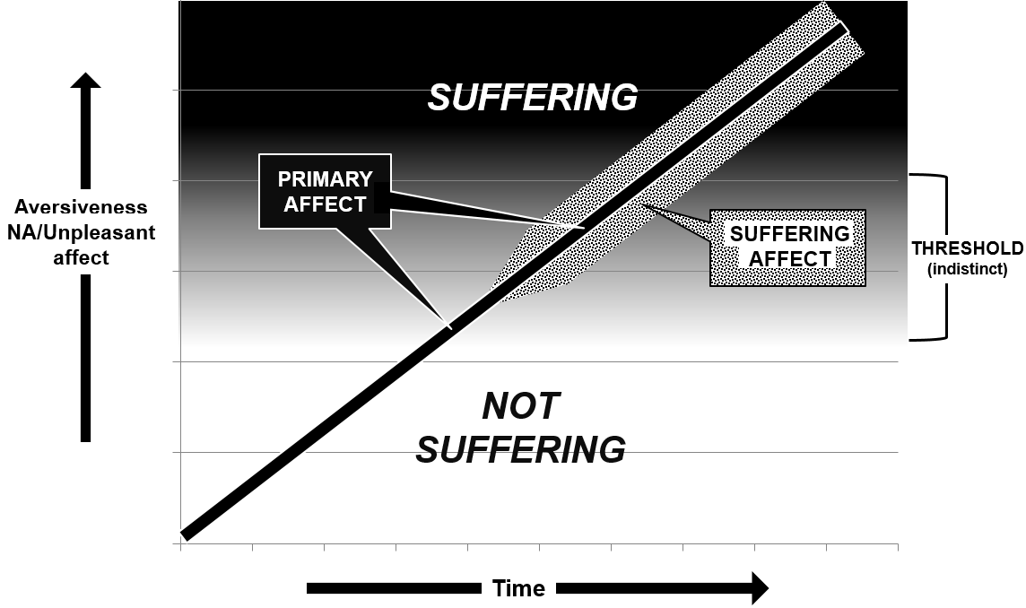
Figure 1a Figure 1b

Suffering as a boost or amplifier mechanism
Barnard and Hurst (1996) characterized suffering as a subjective “state of emergency” in deleterious circumstances. Tomkins (1970) described an amplifying process in which affects “boost the gain” of the drive signals under such deleterious circumstances. For example, a rapidly mounting affect of panic is recruited whenever the organism’s air supply is suddenly jeopardized, such that the drive signal of insufficient oxygen (and/or excess carbon dioxide) is amplified by the sense of panic. This raises a third possibility to explain the nature of suffering: the primary NA undergoes an amplification process when it reaches a certain level.

As noted earlier, an increase in the urgency of a threat is accompanied by a rise in the intensity of the NA, until it reaches the level of suffering. Here the onset of suffering indicates not only that the threat is severe, but also that all lesser defensive coping mechanisms – such as behavioral responses and physiological stress processes – have failed to effectively counter the threat. At this point, a much higher degree of motivation is needed, and it is reasonable to suggest that suffering is (1) the result of, or (2) the cause of, a boost or amplification of the motivation in order to initiate the more demanding efforts required. Such an amplification process would co-exist with either of the two above possibilities. In the first possibility (in which we simply attach the label of suffering when the NA becomes sufficiently aversive, as shown in Figure 1a), suffering would emerge after some (yet unknown) mental process causes a surge of intensity of the primary NA, as depicted in Figure 2a by the sharp rise in the slope of the line. For the second possibility (in which the suffering experience differs qualitatively from less intense NA, as shown in Figure 1b), the added-on suffering affect is itself the amplifier of the primary affect and that which causes the sharp rise in the slope of the line, as depicted in Figure 2b.

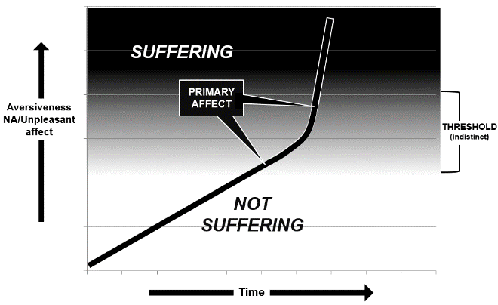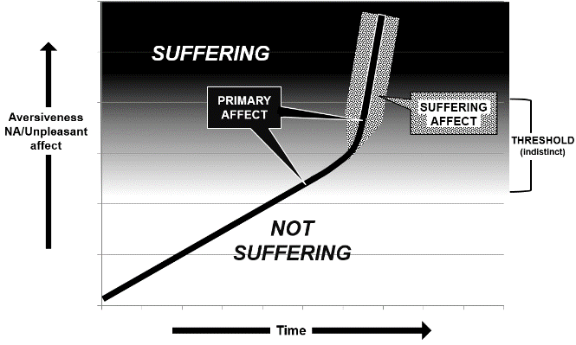
Figure 2a Figure 2b

But how does this matter? The answer is important for our care of animals and our goal of alleviating suffering. If there is an affect of suffering – distinct from the primary affect that elicits it – then it may become possible to develop methods to: (1) ascertain its presence in an individual animal, thereby confirming a state of suffering, and (2) quantify this affective state such that the level of suffering could be determined. This, however, may offer no immediate benefits for animal care, since merely tending to the intense primary NA would achieve the desired objective from the animal’s perspective. The importance would lie primarily in the legal arena, as it could conceivably be of great value as evidence that an animal was or is suffering. None of this, of course, would be in the near future, as we currently lack clear biological markers for even the most well-understood affective states themselves, such as pain, fear, loneliness, and the like.

Changing the suffering threshold: The role of personal control

The threshold concept of suffering has no more important question than “What affects the threshold?”, as having an understanding of this is indispensable for our efforts to alleviate suffering. Clearly for all of the models of suffering discussed above, the alleviation of suffering is best achieved by lessening the primary affect. But this is not always possible, or not possible to the necessary degree or quickly enough. Here, the threshold concept becomes key. Despite the acknowledgement that any threshold is indistinct, if we are able to raise the threshold, we become able to alleviate suffering, in part or in whole. Our current knowledge in this area is limited, but one theme that has received considerable attention is the connection of suffering with a sense of control. Control is here defined as the perception that one has a response available that can lessen the aversiveness of the event – it bestows to the individual the sense that he/she can, at will, terminate the event, make it less probable or less intense, or change its duration or timing. It is now well supported that, for humans and animals, in the presence of an aversive stimulus, control can increase the individual’s ability to tolerate that unpleasant stimulus (Thompson, 1981). A large literature has demonstrated that, for those who perceive that they have the ability to affect the outcomes they experience, (1) the intensity and harmful effects of physiologic and emotional stress are reduced in both humans (Sapolsky, 1994) and animals (Joffe et al., 1973), and (2) coping ability in stressful situations is improved in both humans (Thompson and Spacapan, 1991) and animals (Broom, 1986).

Most discussions of the effect of control on the level of adversity of a stressor use “distress” as the term denoting extreme aversiveness. In humans, Steptoe and Poole (2016) stated that “It is generally found that distress is associated with a perception that events are uncontrollable” and Lundberg and Frankenhaeuser (1978) have argued that how much a task can be controlled is a major determinant of the degree of distress experienced. Other studies have found positive effects of perceived control on distress in response to electric shock and loud noises (reviewed in Thompson, 1981). A series of studies of torture survivors by Başoğlu et al (2007) demonstrated that a greater ability to exercise control over torture stressors was associated with less perceived distress during torture.

Referring specifically to suffering, Cassel (2004) anecdotally found a relationship between suffering and the perception of control, writing that people in pain frequently report suffering from the pain when they do not believe that the pain can be controlled and that the suffering of patients with terminal cancer can often be relieved when they learn how to control their pain. He reports that “Patients who have been rolling in agony, believing their pain beyond relief, will often tolerate the same severe pain without complaint after they have been shown that it can be controlled” (Cassell, 2004). Simply having knowledge about the source of the pain – conceived by some as a form of control (Averill, 1973) – also exerts an effect. Cassel wrote that “patients can writhe in pain from kidney stones and by their own admission not be suffering, because they “know what it is”; they may also report considerable suffering from apparently minor discomfort when they do not know its source.” This kind of effect, when expanded to include pain but without specific reference to suffering, has been extensively studied (e.g., Thompson, 1981) and found in most cases to exhibit a negative correlation between perception of control and self-reported pain.

This empirical and anecdotal evidence suggests that the perception of control, by making unpleasant experiences more tolerable, demonstrably raises the threshold – and thus the onset – of suffering.

Measuring suffering
The measurement of suffering – first, in terms of simply confirming its presence, and second, in determining its level – is the greatest challenge we currently face with animals. One goal of animal welfare science is to develop objective methods of measurement that can provide a scientific rationale on which to conclude whether or not an animal has suffered, rather than rely on subjective assessments of the animal’s situation (Fordyce, 2017). Researchers have developed a number of objective methods for assessing subjective states, including the aversiveness of stressors in animals, which include changes in behavior, physiology (e.g., hormonal, biochemical), brain imaging, and pathology. But at what point increasing aversiveness reaches a level where the description suffering applies is not – at least yet – a scientific determination. Why do we know this? Because individual humans cannot even do it for themselves – that is, for the person to whom they have direct access to subjective mental states. Consider yourself with a barely noticeable toothache (or hunger, or nausea, or anxiety). The pain gradually increases over the next few days until it finally becomes unbearable, forcing you to contact your dentist to be seen. At some point along this timeline, you progressed from a state of not suffering to a state of suffering. Can you pinpoint that time? And what characterizes the change from not suffering to suffering? All of these questions also apply for an unpleasant affective experience that is resolving. When did suffering become not suffering?

With these questions in mind, Dawkins (1990) suggested that the link between motivation and suffering would permit using the former as a proxy for the latter. Using her concept that suffering results when animals are highly motivated, but unable, to perform a behavior, Dawkins proposed that methods able to measure the strength of motivation may be able to ascertain whether a deprivation or aversive stimulus is severe enough to cause suffering. Using as the comparison standard a basic necessity for life (that is, food), the idea was that, if the effort that an animal would make to achieve some objective equals or exceeds that which it would perform to obtain food (while hungry), then we may presume that the effort stems from a motivation to alleviate a state so unpleasant as to constitute suffering (Dawkins, 1990; Kirkden and Pajor, 2006).

The use of motivation measurement for assessing suffering has its most immediate applications in the courtroom. Even with some unavoidable subjectivity, motivation could be “scorable” as mild, moderate, and severe, where the latter would be considered suffering. Using this standard, judgements of whether or not an animal is or was suffering could be based on the current knowledge of how much effort an animal would typically be expected to exert to achieve its objective, in this case alleviating its current adversity.

However, while motivation holds promise as an indicator, and hence potentially evidence, of suffering, there are important limitations with its use. First, some suffering occurs with low-motivation states (e.g., depression, learned helplessness, major illness). Second, on a practical basis, we can’t test each individual animal’s motivation regarding all unpleasant experiences, and for deceased animals, such as those severely neglected or abused, motivation testing cannot be done at all. Yet, to counter this limitation, there are numerous naturally occurring circumstances that may be helpful in estimating motivation. Examples include how aggressive an animal is in protecting a painful body part or fighting off fear-eliciting threats, how hard a dog with separation anxiety tries to get out of its crate, and how far a starving horse will push its head under a wire fence to reach vegetation in the adjoining field.

Final comments
A major challenge we face is to bring together the disparate conceptualizations of suffering into a more unified view and to determine whether suffering is only a descriptive label or, rather, an actual mental experience itself. In addition, it is crucial to develop a science-based, objective means to confirm and measure a state of suffering. For now, there can be no argument that, regardless of the specifics of the nature and measurement of suffering, making every effort we can to protect animals from this experience is of the utmost importance and urgency.

References
Averill, J.R. (1973) Personal control over aversive stimuli and its relationship to stress. Psychological Bulletin 80, 286-303.
Barnard, C. (2007) Ethical regulation and animal science: Why animal behavior is special. Animal Behaviour 74, 5-13.
Barnard, C.J. and Hurst, J.L. (1996) Welfare by design: The natural selection of welfare criteria. Animal Welfare 5, 405-433.
Başoğlu, M., Livanou, M., Crnobaric, C. (2007) Torture vs other cruel, inhuman, and degrading treatment: Is the distinction real or apparent? Archives of General Psychiatry 64, 277-285.
Baumgaertner, H., Mullan, S., & Main, D. C. J. (2016). Assessment of unnecessary suffering in animals by veterinary experts. Veterinary Record 179, 307-307.
Broom, D.M. (1986) Indicators of poor welfare. British Veterinary Journal 142, 524-526.
Broom, D.M. (2008) Welfare assessment and relevant ethical decisions: Key concepts. Annual Review of Biomedical Sciences 10, T79-T90.
Cambridge Dictionary. (2020) Available at: https://dictionary.cambridge.org/us/dictionary/english/gravity, Accessed 11-25-20.
Cassell, E.J. (2004) The Nature of Suffering and the Goals of Medicine, 2nd edn. Oxford University Press, Oxford, UK.
Dawkins, M.S. (1980) Animal Suffering. Chapman and Hall, London, UK.
Dawkins, M.S. (1990) From an animal’s point of view: Motivation, fitness, and animal welfare. Behavioral and Brain Sciences 13, 1-61.
DeGrazia, D. (1996) Taking Animals Seriously. Cambridge University Press, Cambridge, UK.
Fordyce, P. (2017) Suffering in non-human animals. Global Journal of Animal Law 5(1).
Fraser, A.F. (1988) Animal suffering: the appraisal and control of depression and distress in livestock. Applied Animal Behaviour Science 20, 127-133
Fraser, D. and Duncan, I.J.H. (1998) ‘Pleasures’, ‘pains’ and animal welfare: Toward a natural history of affect. Animal Welfare 7, 383-396.
Fredrickson, B.L. (2001) The role of positive emotions in positive psychology: The broaden-and-build theory of positive emotions. American Psychologist 56, 218-226.
Grassian, S. (1983) Psychopathological effects of solitary confinement. American Journal of Psychiatry 140, 1450-1454.
Gregory, N.G. (2004) Physiology and Behaviour of Animal Suffering. Blackwell Publishing, Ames, Iowa.
Heilman, K.M. (2000) Emotional experience: a neurological model. In: Lane, R.D. and Nadel, L. (eds.) Cognitive Neuroscience of Emotion. Oxford University Press, New York, New York, USA, pp. 328-344.
Joffe, J.M., Rawson, R.A., Mulick, J.A. (1973) Control of their environment reduces emotionality in rats. Science 180, 1383-1384.
Kirkden, R.D. and Pajor, E.A. (2006) Using preference, motivation and aversion tests to ask scientific questions about animals’ feelings. Applied Animal Behaviour Science 100, 29-47.
Ledger, R.A. and Mellor, D.J. (2018) Forensic use of the Five Domains Model for assessing suffering in cases of animal cruelty. Animals 8(7), 101.
Lundberg, U. and Frankenhaeuser, M. (1978) Psychophysiological reactions to noise as modified by personal control over noise intensity. Biological Psychology 6, 51-59.
Mellor, D.J. (2016) Updating animal welfare thinking: Moving beyond the “Five Freedoms” towards “A Life Worth Living”. Animals 6, 21.
Panksepp, J. (1998) Affective Neuroscience: The Foundations of Human and Animal Emotions. Oxford University Press, New York, New York, USA.
Sapolsky, R.M. (1994) Why Zebras Don't Get Ulcers: A Guide to Stress, Stress-Related Diseases, and Coping. W.H. Freeman and Company, New York, New York, USA.
Schultheiss, O.C. and Wirth, M.M. (2018) Biopsychological aspects of motivation. In: Heckhausen, J. and Heckhausen, H. (eds.) Motivation and Action, 3rd edn. Cambridge University Press, New York, New York, pp. 407-451.
Seery, M.D. (2011). Resilience: A silver lining to experiencing adverse life events?. Current Directions in Psychological Science 20, 390-394.
Short, C.E. (1998) Fundamentals of pain perception in animals. Applied Animal Behaviour Science 59, 125-133.
Steptoe, A. and Poole, L. (2016) Control and stress. In: Fink, G. (ed.) Stress: Concepts, Cognition, Emotion, and Behavior. Academic Press, Cambridge, Massachusetts, USA, pp. 73-80.
Thompson, S.C. (1981) Will it hurt less if I can control it? A complex answer to a simple question. Psychological Bulletin 90, 89-101.
Thompson, S.C., and Spacapan, S. (1991) Perceptions of control in vulnerable populations. Journal of Social Issues 47, 1-21.
Tomkins, S.S. (1970) Affect as the primary motivational system. In: Arnold, M.B. (ed.) Feelings and Emotions. Academic Press, New York, pp. 101-110.

